**Leader Overview**

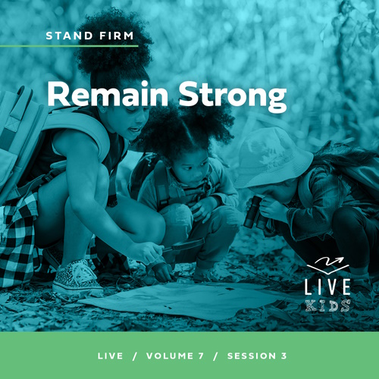

**Volume Overview**

**Stand Firm**

*The world thinks of power as action. Powerful people are able to take control, able to change things. But Jesus blessed the meek, the hungry, and the poor. There is a power this world overlooks. There is power in standing firm in faith. Christians have long stood their ground, not to gain this world’s power but as witnesses to a better world to come. So we stand strong, committed, and bear witness to the world.*

**Session Overview**

**Remain Strong**

*In this* **Live** *session, kids will discover how to remain strong and stand firm against pressures from the world. In our Bible story, Pilate knew Jesus didn’t deserve to die, but he listened to the crowd instead of taking a stand to do what was right. As followers of God, we’re called to remain strong and stand out from the crowd. It won’t always be easy, but God will give us the strength we need to remain strong.*

**Bible Lesson**

Pilate Gives In to the Crowd and Orders Jesus’ Crucifixion

[Luke 23:1–25](https://ref.ly/logosref/Bible.Lk23.1-25), [44–48](https://ref.ly/logosref/Bible.Lk23.44-48)

**Faith Fact**

I will be strong and follow God.

**Faith Verse**

[Ephesians 6:13](https://ref.ly/logosref/Bible.Eph6.13) (NLT)

Put on every piece of God’s armor so you will be able to resist the enemy in the time of evil. Then after the battle you will still be standing firm.

**Preparing for the Session**

**Leader Preparation Time: 20–25 Minutes**

|  |
| --- |
| ***You Will Need***  ***Large Group***   * *Bible* * *Worship songs (Song suggestions: “Won’t Stop Now” by Elevation Worship; “Surrounded (Fight My Battles) Lyric Video” by Bethel Music; “Battle Belongs” Lyric Video by Phil Wickham)* * *For groups not using a phone or tablet only, add:*   *• Projector or TV*  *• Laptop*  *•* ***Faith Fact Slide***  ***• Faith Verse Video*** *or* ***Slide***  ***• Bible Lesson Video***  ***• Teaching Point Slides 1–3***   * *Sheets of paper* * *Marker*   ***Small Group***   * *Bibles for kids in the group to share* * ***Small Group Faith Verse Review****, two copies per group* * *Envelopes, two per group* * *Scissors* * *Painter’s tape, two rolls per group* * ***Small Group Activity Page****, one per kid* * *Pencils, one per kid*   *To access session content and videos from a computer, visit:* [*BibleEngagementProject.com/downloads*](https://bibleengagementproject.com/downloads) |
| ***Getting Ready***  ***Large Group***   * *Download videos and slides if needed.* * *Select worship song(s) and have them ready to play.* * *Read the Bible Lesson Scripture to prepare for Teaching Time.* * *Write a different sin on each sheet of paper (lying, stealing, cheating, disobeying parents, etc.)*   ***Small Group***   * *Print copies of the* ***Small Group Faith Verse Review****, two copies per group.* * *Cut apart the strips and place each set in an envelope.* * *Print copies of the* ***Small Group Activity Page****, one per kid.*   *First time leading Live for* Kids*? Check out the* [*Facilitator Guide*](https://0b769b0ed3569ef9d18b-f88d8272f61086866d50d048b43ef630.ssl.cf2.rackcdn.com/sites/biblengagementproject/Listen_Facilitator_Guide.pdf)*.* |

**Large Group**

**30 Minutes**

*See what’s needed at the beginning of the session.*

**Introduction**

Hi, everyone! I want you to stand up. *(Group response)* We’ve focused on standing firm in our last few sessions. So, stomp each foot one time as we say, “Stand firm,” and then plant your feet firmly on the ground. *(Group response)*

• *As you say,” Stand firm,” stomp with each foot to emphasize the words. Have the kids follow you.*

Now, show me your biggest and best muscle pose. *(Group response)* Say, “Remain strong,” with me. *(Group response)* You guessed it! Today, we’ll talk about how to remain strong no matter what we face. Go ahead and sit down now. *(Group response)*

I’m not actually talking about physical strength and our muscles though. Remaining strong in our faith in God doesn’t require strong muscles. What kind of strength do you think it requires? *(Allow responses.)* It requires spiritual strength. How do we gain the spiritual strength we need to remain strong even though we face many pressures in the world? *(Show the Bible.)* We remain strong by following God and doing what He tells us to do in His Word instead of going along with the crowd. That won’t always be easy, but God can give each of us the strength we need to face those pressures head on.

• *Insert a personal story about a time when you had to stand up against the pressure to follow the crowd and followed God instead. Try to keep it light and something kids can relate to if possible.*

• *If you can’t think of a personal story immediately, tell a story about someone else who stood up against pressure and followed God.*

**Faith Fact**

We will never be strong enough on our own, but the Bible tells us that God is strong in our weakness. Our Faith Fact today is **I will be strong and follow God**.

• *Show the* ***Faith Fact Slide.***

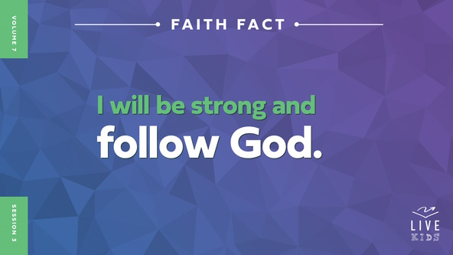

Would you rather try to do things only in your own strength or rely on God’s strength? *(Group response)* God’s strength is stronger than anyone or anything else we could possibly face. Why would we ever try to do things in our own strength? We’ll find out later about someone in the Bible who did exactly that, and it didn’t work out well. Let’s say the Faith Fact a few more times. Each time we say the Faith Fact, strike a different muscle pose. Let’s go! **I will be strong and follow God**.

• *Lead the kids in saying the Faith Fact a few more times, striking a different muscle pose each time.*

**Game**

**Push-Up Challenge**

Raise your hand if you think you are really strong. *(Group response)* Just for fun, we’ll start with a strength challenge today. Are you up for that? *(Group response)* one of the best exercises to test someone’s total body strength is the push-up. How many push-ups do you think you can do? Shout the number out when I say, “Go.” Go! *(Group response)*

We’ll do push-ups until we drop. Literally. The last few kids still in the game will be declared the strongest. Who wants to volunteer for the push-up challenge? Everyone who volunteered can get in push-up position.

• *Have the volunteers get out of their seats and get in the push-up stance. If space is limited, have kids pair up and take turns.*

• *Ask other volunteers to watch for kids who fall to the ground or have poor form.*

Okay, each time I count, you’ll do a push up. Let’s see who can do the most.

• *Allow the kids to continue doing push-ups until only a few kids are still going. Declare them the strongest kids in the group.*

Great job! That was quite a workout! Who broke a sweat during that game? *(Group response)* Push-ups are hard work. Physical strength is great, but spiritual strength is even more important.

Don’t be discouraged if you couldn’t complete this challenge. The important thing is that we accept God’s challenge to each of us: Remain firm in Him and don’t give in to the pressures of this world. God has called us to do the hard work of standing up against pressure from others to follow the crowd. Following God will not always be popular or an easy choice to make. It takes spiritual strength to stand firm against peer pressure and do the wrong things.

**Worship**

I’m so thankful that I’ve made the choice to be on God’s side! I know I feel spiritually stronger when I worship God and allow the Holy Spirit to fill me with His power. Worship isn’t only singing. Worship is also a way to fight our battles against the enemy. Let’s allow God to strengthen us as we worship Him now.

• *Lead the kids in singing one or two praise songs. See suggestions at the beginning of the session.*

**Bible Lesson**

I already feel stronger after singing and worshipping God. Let’s pray and ask God to guide us through our time of learning from His Word today.

**Prayer**

|  |
| --- |
| *Dear God, thank You for being our strength when we are weak. Help us to learn more from Your Word about how to be strong in You. Amen.* |

**Video Intro**

Just before we look at the Bible story, let’s check in with Dash and watch this video.

• *Play* ***Bible Lesson Video****.*

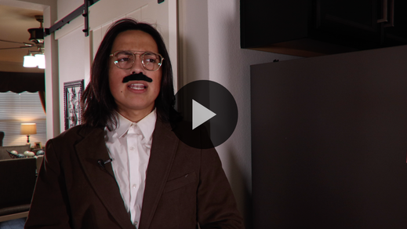

**Bible Story**

**Pilate Gives In to the Crowd and Orders Jesus’ Crucifixion**

That video was a great lead-in to our Bible story today! Dash’s friend was determined to get Dash to watch that movie. Sometimes it’s really hard to be strong and choose to do the right thing when others are pressuring us.

You might recognize today’s Bible story. It’s part of Jesus’ story that we talk about at Easter. We often learn from positive examples of people in the Bible, but today we’ll learn what *not* to do from someone else in Jesus’ story. We’ll see that it’s hard to stand up against pressure from others when they want us to do wrong things, but the consequences of giving in to that pressure can be much worse.

**Teaching Time**

|  |
| --- |
| ***You Will Need***   * *Sheets of paper* * *Marker*   ***Getting Ready***   * *Write a different sin on each sheet of paper (lying, stealing, cheating, disobeying parents, etc.)* |

The events leading up to what happened in today’s Bible story may be familiar to many of us. Jesus had done many wonderful things like teach, heal, and perform miracles in the last three years of His life. There were some religious leaders who didn’t like what Jesus had been doing. In fact, they hated Jesus and His teachings so much that they wanted to find a way to arrest Him and have Him killed.

They finally got Judas, one of Jesus’ disciples, to betray Jesus and hand Him over to them. They offered Judas thirty pieces of silver as his payment, and he accepted it! Can you believe one of Jesus’ closest friends was willing to do that? *(Group response)*

The night that Jesus was betrayed, He had taken His disciples to the Garden of Gethsemane to pray. Jesus knew that night would be His last one with His disciples before His death. When the soldiers arrived, Judas betrayed Jesus with a kiss, and Jesus was arrested. The religious leaders brought Him before the Roman governor, a man named Pilate.

Our Faith Fact reminds us to be strong and follow God no matter what. As we will soon learn, Pilate was an example of what *not* to do when we are pressured by others to do the wrong thing. Let’s read about Pilate’s big mistake. Grab your Bible or pull up a Bible app on your device. Turn to [Luke 23](https://ref.ly/logosref/Bible.Lk23).

• *In order to keep Large Group time moving along, we recommend that the leader reads the Scripture portions aloud (*[*Luke 23:1–25*](https://ref.ly/logosref/Bible.Lk23.1-25)*,* [*44–48*](https://ref.ly/logosref/Bible.Lk23.44-48)*).*

• *Optional: Remind the kids to mark this place with their Bible bookmark so they can read it on their own at home.*

**1. Pilate believed that Jesus was innocent.**

• *Show the* ***Teaching Point 1 Slide.***

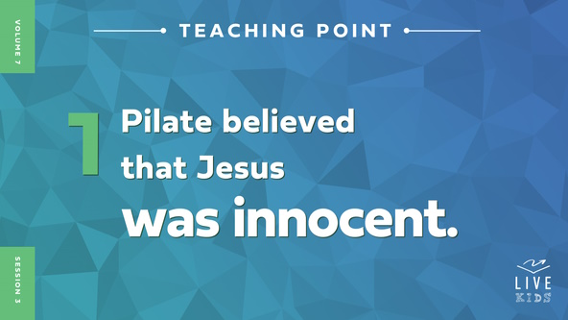

• *Read* [*Luke 23:1–15*](https://ref.ly/logosref/Bible.Lk23.1-15)*.*

As I said earlier, Jesus was arrested and ended up going before the Roman governor Pilate for a trial. What had Jesus done wrong to deserve to be arrested and put on trial? *(Allow responses.)* Nothing! Jesus was completely innocent. In fact, we know that He had never sinned, not even once.

• *Hold up the sheets of paper with sins on them as you talk about them.*

Think about it this way. Jesus never once lied to someone. Jesus never stole anything, not even a piece of candy. Jesus never cheated on a test. He didn’t disobey His parents. Can you imagine growing up with Jesus as a brother? He was literally perfect!

Despite all this, Jesus was facing the possibility of death, and Pilate had the authority to save Him or give the order for Him to be killed. Pilate himself said that Jesus was completely innocent, but the crowd was determined to get Him killed. When Pilate found out that Jesus was from Galilee, he tried to hand off Jesus to Herod Antipas who was the leader of Galilee to make the decision about Jesus’ fate.

Herod questioned Jesus, but Jesus never said a word. Finally, Herod sent Jesus back to Pilate because Herod also found Him to be innocent. How is it possible that Jesus still ended up being sentenced to death after both Pilate and Herod found Him innocent? We’ll learn the very sad answer to that question in the next part of this chapter.

**2. Pilate was too weak to stand up to the crowd.**

• *Show the* ***Teaching Point 2 Slide.***

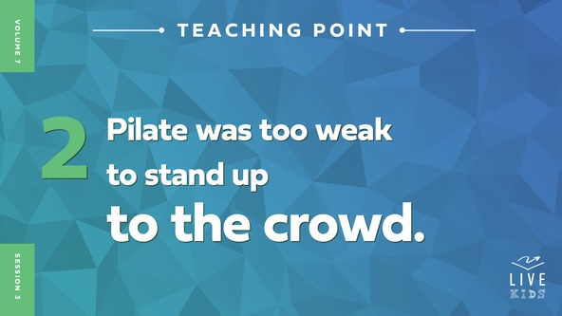

• *Read* [*Luke 23:16–25*](https://ref.ly/logosref/Bible.Lk23.16-25)*.*

The entire time Jesus was on trial before Pilate, the crowd was pushing for Jesus to be crucified. They came up with reason after reason why Jesus deserved to die. They lied and said that He was telling people not to pay their taxes. They said He had told people that He was the king of the Jews and His teachings were causing riots. None of their reasons were true or worthy of His death.

But no matter what Pilate said, the crowd continued to shout and demand Jesus’ death. They even asked for a known murderer to be released from prison instead of Jesus. Imagine how Pilate felt in that moment with the crowd shouting louder and louder at him, “Crucify him! Crucify him!”

Let’s see what it’s like to be part of a loud crowd like that, but let’s yell something good. We’ll pretend to be a crowd and shout, “Jesus,” as loud as we possibly can for five seconds. When I lift up my arm, start shouting, “Jesus.” When I put my arm down, stop shouting. Ready? Go!

• *Raise arm and get kids to shout as loud as possible. If they aren’t very loud, encourage then to be even louder. Then lower your arm.*

The crowd in our Bible story shouted louder and louder, demanding that Jesus be killed. What did Pilate do? *(Allow responses.)* Eventually Pilate gave into the crowd and sentenced Jesus to death. The Bible never says that Pilate decided Jesus was worthy of death or that he changed his mind about Jesus’ innocence. He simply couldn’t stand up against the pressure of the crowd shouting at him. Was that fair to Jesus? *(Group response)* Definitely not!

**3. Jesus proved His innocence on the Cross.**

*Show the* ***Teaching Point 3 Slide.***

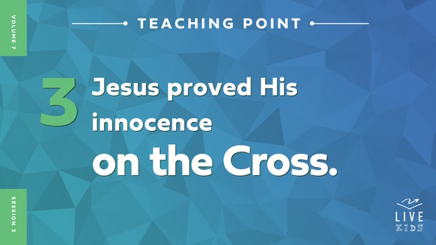

• *Read* [*Luke 23:44–48*](https://ref.ly/logosref/Bible.Lk23.44-48)*.*

So, Jesus, a completely innocent and perfect Man, was sentenced to death and handed over to die. Crucifixion was one of the worst ways you could punish and kill someone. It was usually done only for serious criminals and murderers. However, Jesus had to endure such a horrible death because an angry crowd pressured Pilate into sentencing Him to death. Do you ever say, “That’s not fair!” when you get in trouble? *(Group response)* There was nothing fair about Jesus’ death sentence, but He had to go through it anyway.

Could God have chosen to let Jesus walk away from the whole thing? *(Allow responses.)* Absolutely! God has the power to do anything. So why did Jesus go through such a horrible death? *(Allow responses.)*

Jesus gave His life after living perfectly and innocently to save all of us from our sins and forgive all our sins. Have you ever had someone take the blame or punishment for you when you deserved it? *(Group response)* That’s what Jesus did for us on a very high level.

Jesus chose to die as a substitute, or sacrifice, for all of us. Because Jesus had never sinned, His death paid the price for all our sins. Jesus dying on the Cross made some people realize that He really was who He said He was. The Roman officer who was in charge of Jesus’ crucifixion even declared that Jesus really was innocent. Even while Jesus was near death and suffering on the Cross, He was an incredible example for all of us of love and compassion for others.

**Prayer and Response**

*Consider playing a worship song softly in the background while kids pray.*

Can you imagine how Pilate felt after He sentenced Jesus to death? *(Group response)* Most likely, he regretted sentencing a Man he knew to be innocent to a horrifying death. But that is exactly what happened because Pilate chose to give into the pressure from the crowd instead of doing what he knew was right. Pilate made a huge mistake.

It’s easy for us to look at Pilate and think he was crazy for listening to the crowd, but we sometimes do the same thing. It’s much easier to go along with what everyone else is doing or telling us to do instead of standing up for what we believe in. In our own strength, we will most likely fail to stand up against those pressures when they come. But, we don’t have to rely on our own strength. We can choose to ask God to fill us with His power and strength. Then, we can live what our Faith Fact says. Say it with me. **I will be strong and follow God.**

Let’s pray and ask God to help us stay strong. We can push back against the pressure to do what everyone else is doing when we know it doesn’t please God.

**Prayer**

*Optional: Have the kids repeat phrases of the prayer after you.*

|  |
| --- |
| *Dear God, thank You for this reminder to always follow You instead of the crowd. Help me to not to be like Pilate but to stand up against the crowd when they want to keep me from following You. Amen.* |

**Faith Verse**

Our Faith Verse tells us how to be strong as we follow God too. It reminds us to put on the armor of God. Let’s say our Faith Verse and do the actions together.

• *Play* ***Faith Verse Video****.*

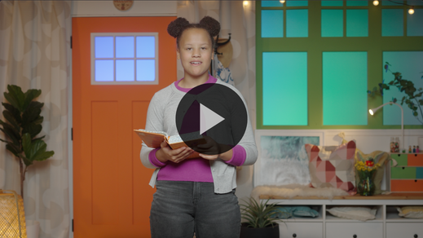

[Ephesians 6:13](https://ref.ly/logosref/Bible.Eph6.13) (NLT)

Put on every piece of God’s armor so you will be able to resist the enemy in the time of evil. Then after the battle you will still be standing firm.

Every piece of God’s armor is important to help us remain strong against the plans and tricks of the enemy. We can’t be lazy about spending time with God and reading His Word. We need to be strengthened daily to face what the enemy has in store for us. With God’s strength, we can stand firm.

**Faith Fact**

Before we go to our small groups, let’s review our Faith Fact again. **I will be strong and follow God.**

• *Show the* ***Faith Fact Slide****.*



Let’s say our Faith Fact together and flex our muscles one more time. **I will be strong and follow God.** Remember to allow God to give you the strength you need. He will help you face any peer pressure you might experience this week.

• *Dismiss kids to Small Group time or to go home if your group time ends here.*

**Small Group**

**30 Minutes**

*This section can be done in conjunction with the large group or on its own if you do small groups with your kids. During Small Group time, the goal is to connect the kids with the Word of God and to each other. All activities are led by the small group leader.*

**Group Connection**

**Stay Strong!**

Sometimes we might need to be strong and stand firm in our faith on our own. Other times, we can help each other remain strong against the pressures we face in this world. We should lean on other Christians because we are stronger together. We can do even more amazing things for God when we stand firm together.

Let’s try an activity to practice that. Stand up and link arms with each other. You’ll attempt to stay strong and remain together as I lead you quickly around the room. If anyone breaks the link, the round is over, and we’ll try it again.

• *Stand at the front of the line and link arms with one of the kids.*

• *Each of the kids will link arms with the person next to them, forming a long chain.*

• *Quickly but safely lead the kids around the room, turning and twisting along the way. If anyone breaks the chain, stop the round.*

• *Go to the opposite end of the line and play again.*

• *Optional: Allow kids to lead the group if they can do so safely.*

Sometimes life can feel like we are being pulled through twists and turns like this game did. If we remain connected to God and follow Him, He will give us the strength to resist the pressure from the crowd to do the wrong things. Let’s say our Faith Fact as a reminder. **I will be strong and follow God.**

**Bible Lesson Recap**

• *If small group activities are not immediately following large group time, you may want to read the Bible story passage before the discussion.*

|  |
| --- |
| ***You Will Need***   * *Bibles for kids in the group to share*   *No prep needed for this activity.* |

**Bible Story Review: Pilate Gives In to the Crowd and Orders Jesus’ Crucifixion**

[**Luke 23:1–25**](https://ref.ly/logosref/Bible.Lk23.1-25)**;** [**44–48**](https://ref.ly/logosref/Bible.Lk23.44-48)

We can learn a lot from Pilate’s bad example of giving in to the crowd. Even though Jesus had never done a single wrong thing in His life, He still ended up being arrested and brought to trial. Some of the religious leaders hated Jesus and told lies about Him to turn the crowds of people against Him. Pilate, a Roman governor at the time, was not fooled by their lies like the crowd was. He knew that Jesus was innocent and didn’t deserve to die. But, Pilate didn’t have God’s strength to back him up.

The crowds continued to demand Jesus’ death. Pilate was too weak to stand up against the pressure from the crowd, and he eventually gave in to their demands. How could Pilate have possibly sentenced an innocent man like Jesus to death? That’s what happens when you listen to the crowd instead of follow God’s leading. I’m sure Pilate regretted his decision later, but there was no going back. Pilate sent Jesus, someone he knew was innocent, to a painful death because of his own inability to stand up against the crowd.

• *Give each kid a Bible and read the Bible story together.*

**Group Discussion**

*Feel free to use all or just a few questions as a jumping-off place for good discussion. Questions marked with * are designed for more conversation. Adjust the questions based on the age or maturity of your group. Typically, older kids will be able to dive a little deeper than younger ones.*

**Questions**

Who thought Jesus was innocent?

* Why do you think Pilate believed Jesus was innocent?

Why did Pilate end up sentencing Jesus to die?

* How do you think Pilate’s life was affected by his decision to punish Jesus that day?

* How did Pilate’s decision affect others?

What would you have done if you were in Pilate’s position?

* What can we learn about what not to do from Pilate’s choices?

How can you remain strong when you face the pressure to do the wrong thing?

**Live It**

**Faith Fact**

Our Faith Fact today is **I will be strong and follow God.** Who do you think is stronger: you or God? *(Group response)* The answer to that question is a no-brainer. God is so much stronger than anyone or anything else. That’s why it makes no sense for us to try to do anything on our own or listen to anyone other than God.

**Challenge**

So, how can we make sure we are living our life and making decisions based on God’s strength instead of our own? *(Allow responses.)* This week pause before you make any decision and quickly ask God how He wants you to handle it. You will know you are doing what God wants you to do when you feel peace in your heart about the decisions you make. God will strengthen you to make the right decisions even when others are pressuring you to make the wrong ones.

**Prayer**

*Finish group discussion by sharing prayer requests and praise reports. Keep track of your small group’s prayer requests and review them each time you meet.*

• *Have kids share and pray for each other’s prayer requests.*

|  |
| --- |
| *Dear God, help us to ask You about the decisions we make every day. We want to make sure we are acting in Your strength instead of our own. Amen.* |

**Faith Verse Review**

|  |
| --- |
| ***You Will Need***   * ***Small Group Faith Verse Review****, two copies per group* * *Envelopes, two per group* * *Scissors* * *Painter’s tape, two rolls per group*   ***Getting Ready***   * *Copy the* ***Small Group Faith Verse Review****, two copies per group.* * *Cut apart the strips and place each set in an envelope.* |

Let’s continue learning our Faith Verse together. Our Faith Verse is [Ephesians 6:13](https://ref.ly/logosref/Bible.Eph6.13). It teaches us how to stand firm in our faith and put on the armor of God. Let’s practice it together.

• *Show* ***Faith Verse Video****.*



[Ephesians 6:13](https://ref.ly/logosref/Bible.Eph6.13) (NLT)

Put on every piece of God’s armor so you will be able to resist the enemy in the time of evil. Then after the battle you will still be standing firm.

Let’s say it together a couple of more times. I hope that you are memorizing this powerful verse.

• *Say the verse as a group a couple of times.*

**Faith Verse Fun**

**Tower Power Race**

Our Faith Verse is about putting on God’s armor to protect ourself from the enemy. Throughout history, cities have protected themselves from their enemies by building huge walls and towers. We’ll form two teams. Each team will create a tower with the words of the Faith Verse by taping them to the wall. The first team to finish will win that round.

• *Give the kids the strips of verse words and the tape.*

• *Optional: Have the kids build the tower on the floor*

• *Play until one team wins.*

It was a lot of fun creating those towers together. Keep practicing the Faith Verse on your own this week as a reminder of how God helps you to stand firm.

**Activity Page**

**God’s Armor**

|  |
| --- |
| ***You Will Need***   * ***Small Group Activity Page****, one per kid* * *Pencils, one per kid*   ***Getting Ready***   * *Print copies of the* ***Small Group Activity Page****, one per kid.* |

Our Faith Verse reminds us to put on every piece of God’s armor. That’s designed by God to help us be strong and follow Him. Do you know what all those pieces of armor are? *(Group response)* Let’s find out more about that.

• *Hand out a copy of the* ***Small Group Activity Page*** *and a pencil to each kid.*

Let’s start with our Faith Verse, and then keep reading in [Ephesians 6:13**–**18](https://ref.ly/logosref/Bible.Eph6.13-18). I’ll stop when I come to a piece of God’s armor so we can talk about what it is as you write it on the Activity Page.

• *Read the passage. Pause and help kids complete the names of the pieces of armor.*

Now you have a much better idea of what God has provided for us. His armor will help us to be strong and follow Him. Let’s say our Faith Fact as a reminder. **I will be strong and follow God.**

**Dismissal**

While it’s sad to think about the decision Pilate made for Jesus to be killed, we can learn a lot from Pilate’s mistake. God has called us to follow Him instead of the crowd. Let’s pray and ask God to strengthen us as we continue to follow Him.

**Prayer**

|  |
| --- |
| *Dear God, thanks for the examples in the Bible to help us learn how to follow You better. Help us to follow You instead of giving in to the pressure from others this week. Amen.* |

**Faith Fact Recap**

• *Show the* ***Faith Fact Slide****.*



Standing firm requires us to depend on God’s strength instead of our own strength. Remember today’s Faith Fact as you go through your week. Let’s say it together one more time. **I will be strong and follow God.**

• *Send home the* ***Small Group Activity Page.***

• *Remind parents that there are* ***Family Devotions*** *available on the app to do with their kid.*

• *Tell everyone the date and time for the next session.*